**Lisse EcouteTM Chocolate: Market Entry Analysis**

When one speaks about Chocolate it is inclusive of all chocolate products that span the chocolate confectionery industry. The major product lines are primarily chocolate bars, candy bars and pralines. The five major chocolate manufacturers in the world are Mondelez International, Mars, Nestlé, Ferrero and Hershey. [1] The current global and local chocolate markets are quite crowded in terms of market share; but there are new entrants in the market every year looking to gain small sliver of market share no matter how challenging. The one particular market segment in the chocolate realm is the high end chocolate market. This particular segment is growing especially in local market areas due public tastes when it comes to quality chocolate. Once only seen as confectionary for children; the high end chocolatiers from Belgium, France and Luxembourg have concentrated their efforts on breaking into the adult market by creating smother textures ranging in sweetness and bitterness. This has opened the palates of a new and older generation of chocolate fans. [ 1-2 ]

The United States, the world's largest chocolate market, is forecasted to be valued at $30 billion in 2021. The demand for chocolate has increased as customers have begun to prefer sugar-free, premium and dark chocolates. They also are looking for chocolates with antioxidants. Last year, 65% of U.S. chocolate revenue was in the seasonal and count line segments. The majority of chocolate candies were purchased at supermarkets and other retail stores. The chocolate confectionery market in the North American Free Trade Agreement countries totaled $20.9 billion in 2014. The fastest growing country was Mexico. In 2014, the U.S. had revenue totaling $18.8 billion. Canada had $1.4 billion and Mexico $655.0 million. In 2019, the U.S. is forecasted to be valued at $19.9 billion followed by Canada at $1.6 billion and Mexico at $731.2 million.

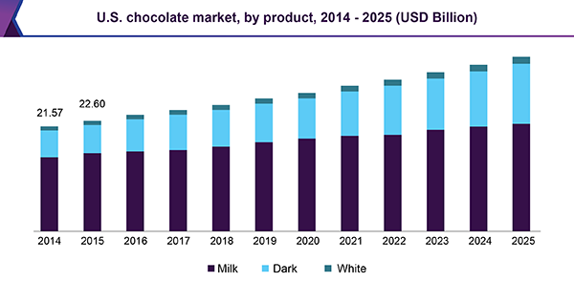

U.S. accounted for the largest share in the North America chocolate market in 2016. Manufacturers are involved in initiatives to position chocolate as a healthier product by increasing the content of dark chocolate, fruits, nuts, and other ingredients to nutritive value and lower calorie indulgence. This is expected to be one of the reasons behind the dominance of U.S. in the North America market for chocolates.

Chocolate cups are used by premium bakeries to enhance the aesthetic value of their products. These stores serve puddings, mousse, custards, and other chocolate-based desserts and have a high-income group customer base. This trend is expected to propel demand for chocolate in North America over the forecasts period.

Ball roasters have been widely used but are now being replaced by fluid bed roasters, an advanced technology with a similar working principle. These technologies are preferred when flavor of a product is of high importance. Fluid bed roasters are also used in large industrial environments owing to their conducive characteristics, high roasting temperature, and capacity to roast large volume of beans at a time.

Fluctuating prices of raw material is a key factor influencing cost of production in the industry, thereby influencing profitability of manufacturers in North America. Cocoa forms a key ingredient in manufacturing this product and has no substitute. Volatility in prices of cocoa in the global market can be attributed to disturbances and irregular supply. This is likely to restrain market growth over the forecasts period.

**Cassiopeia Entertainment GroupTM** with its high end premium Belgian Chocolate -***Lisse EcouteTM*** has the ability to penetrate US local markets comfortably according to recent data from Grand View Research Associates.

**Report Scope**

|  |  |
| --- | --- |
| **Attribute** | **Details** |
| Base year for estimation | 2016 |
| Actual estimates/Historical data | 2014 - 2016 |
| Forecasts period | 2017 - 2025 |
| Market representation | Volume in kilo tons, revenue in USD million, and CAGR from 2017 to 2025 |
| Regional scope | North America |
| Country scope | U.S., Canada and Mexico |
| Report coverage | Revenue forecasts, company share, competitive landscape, growth factors, and trends |
| 15% free customization scope (equivalent to 5 analyst working days) | If you need specific market information, which is not currently within the scope of the report, we will provide it to you as a part of customization |

***Reference: Grand View Research Associates***

New product development and innovative marketing were among the major growth strategies adopted by manufacturers such as Mars Inc.; Nestle; and Hershey’s. Lindt resorted to improving customer experience with its strong distribution channel and a number of exquisite boutiques to increase its market share and augment market revenues.

The industry is characterized by continuous technological advancements to produce refined products with low sugar content in a bid to gain market share. Companies also resort to introduction of one-of-a-kind, gourmet sweets for special occasions. The vast distribution network of industry players has reduced selling and distribution costs, making them prominent players in the market.

**References:**

1: https://www.grandviewresearch.com/industry-analysis/north-america-chocolate-market

2: https://www.confectionerynews.com